CCSA104 Practical Assignment: Managing Security Policies
Course: CCSA104 Security Policy Management (2 credit units) · Companion to Lab 4A: Manage the Security Policies · Total: 100 marks (Practical 70, Theory 30)
Student name | DESMOND BUH KUUM | Student ID
Date | Sunday 8, November 2026 | Score | / 100

1. Overview
In Lab 4A you saw how a Security Policy is created in SmartConsole, stored on the Security Management Server and enforced by the Security Gateway. In this assignment you will apply those skills on your own. You will build an Access Control rulebase for a small company, organise it with sections, configure security zones and Hide NAT, then publish, install and verify the policy using logs. A short theory section follows the practical work.
By completing this assignment you will show that you can:
- Explain the purpose of Security Policies and apply the Positive Control (whitelist) model.
- Configure the essential elements of a policy: rules, the Stealth rule, the Cleanup rule, sections, zones and NAT.
- Follow the basic workflow: create, publish, install and verify.
- Use features that support policy management: Global Properties, Policy Packages and Installation History.
Tools: SmartConsole connected to the Security Management Server, one Security Gateway, and test hosts in the Internal, DMZ and External networks.

2. Instructions
- Work individually and complete every task in the lab environment.
- Name objects and rules exactly as shown. Names appear in logs and are used for marking.
- Take a labelled screenshot for every item marked Evidence (for example, Task 3 – Rulebase).
- Publish at the end of each task so your work is not lost. Install policy only when a task tells you to.
- Menu wording can differ slightly between versions. If a menu item looks different, use the lab guide or the help icon in SmartConsole.

3. Scenario
Orion Logistics runs a small head-office network protected by one Check Point Security Gateway, managed from a Security Management Server. The network has three segments: an Internal LAN for staff, a DMZ hosting the public web and mail servers, and the External network (Internet). You are the security administrator. Management wants a policy that follows the Positive Control Model: allow only what is needed, drop everything else, and log it.
Create these objects in Task 2. The addresses are examples. Use the addressing in your lab topology, and use the name of your own gateway object wherever the tasks say Gateway.
Object name | Type | Example value | Purpose
Internal_LAN | Network | 10.1.1.0 / 255.255.255.0 | Staff network
DMZ_Net | Network | 172.16.10.0 / 255.255.255.0 | DMZ network
Admin_PC | Host | 10.1.1.101 | Administrator workstation
Web_Server | Host | 172.16.10.20 | Public web server
Mail_Server | Host | 172.16.10.25 | Mail server
External_DNS | Host | 192.9.100.10 | External DNS server

4. Part A: Practical Tasks (70 marks)

Task 1: Explore the default policy (5 marks)
- The Policy Package Name is Standard.

Cleanup rule property | Value
Name | Cleanup rule
Source | Any
Destination | Any
Services & Applications | Any
Action | Drop
Track | None
Install On | Policy Targets

- Three Categories in Global Properties
- Firewall

- NAT - Network Address Translation

- Stateful Inspection

Policy Package Name that exists: Standard

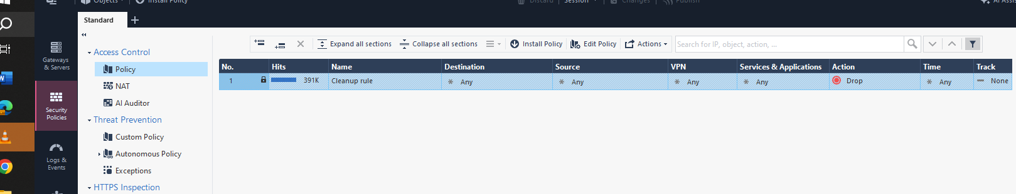
Evidence: a screenshot of the default rulebase with the extra columns visible, and your table of Cleanup rule values.

Task 2: Build the Access Control rulebase (20 marks)
Insert new rules above the Cleanup rule so that the rulebase matches the table below. SmartConsole numbers rules automatically, so the positions shown are the final positions after Task 5 adds rule 4.
Final position | Name | Source | Destination | Services & Applications | Action | Track
1 | Admin Access | Admin_PC | Gateway | ssh, https | Accept | Log
2 | Stealth Rule | Any | Gateway | Any | Drop | Log
3 | Inbound to DMZ | Any | Web_Server, Mail_Server | http, https, smtp | Accept | Log
4 | Internal to DMZ | added in Task 5
5 | DNS Out | Internal_LAN | External_DNS | dns (UDP and TCP) | Accept | Log
6 | Internal Web Out | Internal_LAN | Any | http, https | Accept | Log
7 | SMTP Out | Mail_Server | Any | smtp | Accept | Log
8 | Cleanup Rule | Any | Any | Any | Drop | Log

The Cleanup rule already exists. Do not recreate it. Change its Track setting to Log so that dropped connections are recorded, and leave it at the bottom.
Evidence: a full screenshot of the rulebase showing the number, name, source, destination, services, action and track columns.
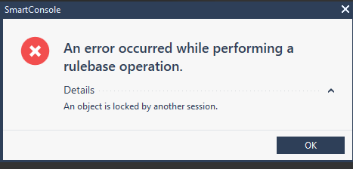
ERROR I FACE WHILE CARRYING TASK 2 AND SUBSQUENTLY COULDN’T DO TASK 2, 4 AND 7

Task 4: Organise the rulebase with sections (5 marks)
Right-click the rulebase, choose New Section Title, and select Above or Below to create four sections. Place each rule in the correct section.
Section title | Contains
Management and Protection | Rules 1 and 2
DMZ Services | Rules 3 and 4
Outbound Access | Rules 5, 6 and 7
Cleanup | Rule 8

Collapse and expand at least one section, and edit one section title and change it back.
Evidence: a screenshot with all sections expanded and a second screenshot with one section collapsed. Add one sentence stating whether sections affect rule enforcement order and whether they are sent to the Security Gateway.

Task 6: Configure Hide NAT (10 marks)
- Open the Internal_LAN object, go to its NAT page, enable automatic address translation rules, choose Hide, and hide the network behind the gateway.
- Publish your changes.
- In the Security Policies view, open the NAT rulebase and locate the rule or rules created automatically for Internal_LAN.
- In your own words, explain why this is an automatic NAT rule rather than a manual one, what many-to-one translation means, and what the gateway does with the source port.

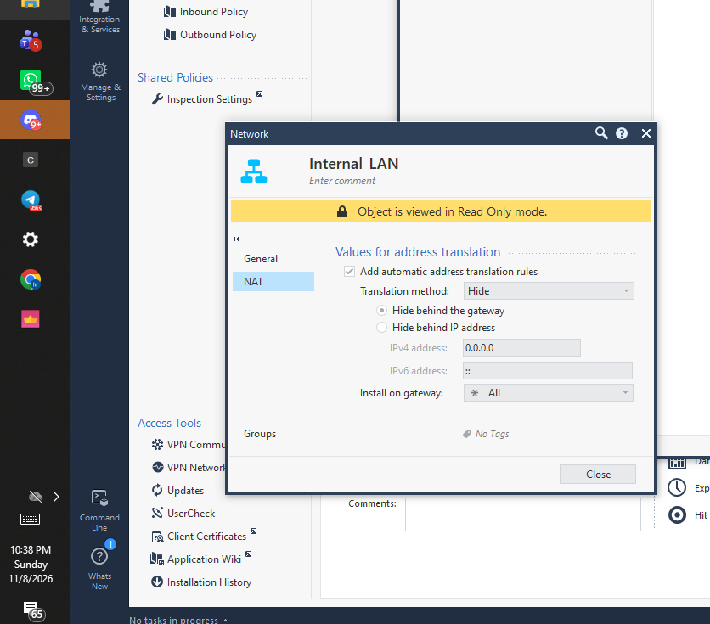
Evidence: a screenshot of the Internal_LAN NAT settings,

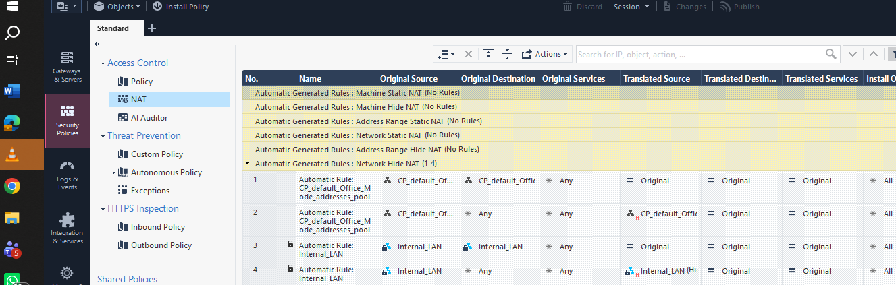
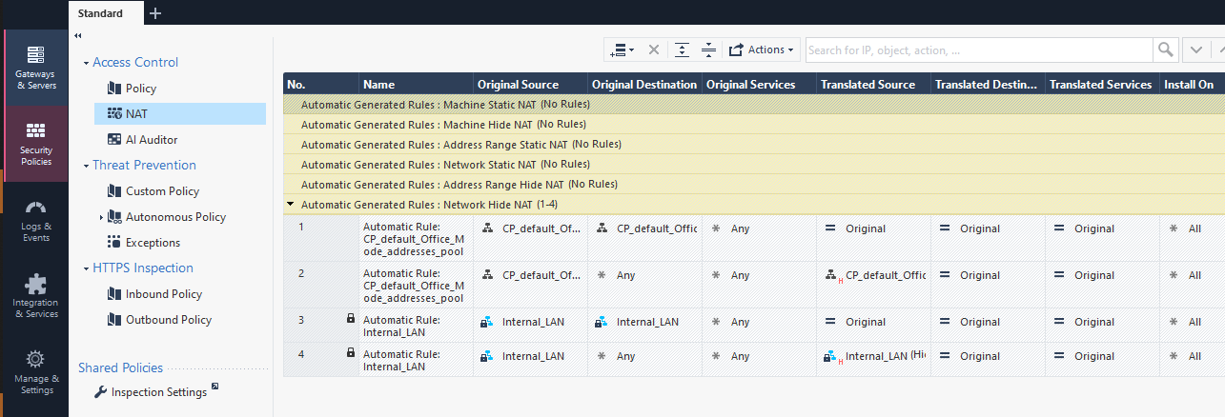
Evidence: a screenshot of the NAT rulebase with the automatic rule or rules, and your written explanation.
For written explanation.
- Why an automatic rule rather than a manual one: Check Point automatically generates this NAT rule based on the settings configured directly inside the Internal_LAN object's NAT page, eliminating the need to write custom manual static source/destination IP mapping rows.
- What many-to-one translation means: Multiple private IP addresses from the internal Internal_LAN subnet are mapped to share a single public routable IP address (the external interface address of the Security Gateway) when communicating outward to the Internet.
- What the gateway does with the source port: Because many internal hosts share a single public IP address, the gateway performs Port Address Translation (PAT). It replaces the original source port with a unique dynamically assigned high-order source port on the gateway, allowing it to correctly track and demultiplex returning traffic back to the right internal client.

Task 7: Rule order experiment and Installation History (5 marks)
- Add a temporary rule named TEMP Block Internal (Source Internal_LAN, Destination Any, Services Any, Action Drop, Track Log) above Internal Web Out. Publish and install. Repeat test T4 and note which rule matches.
- Move TEMP Block Internal below Internal Web Out. Publish and install. Repeat T4 and note which rule matches. Explain the difference.
- Delete the temporary rule, then publish and install again.
- In the Security Policies view, open Access Tools and then Installation History. Identify the installation that contained the temporary rule and open its read-only or audit view. Do not revert unless your instructor says so.
Evidence: log screenshots for steps 1 and 2, the Installation History screenshot, and a three-sentence explanation of why specific rules belong above general rules.

5. Part B: Theory Questions (30 marks)
Answer in your own words.

Section B1: Multiple choice (5 marks, 1 mark each)

Q1: B

Q2: A

Q3: C

Q4: D

Q5: B

Section B2: Short answers (15 marks, 3 marks each)

Q6. Explicit rules, implied rules, and implicit cleanup Explicit rules are the rules an administrator creates and manages in the Access Control rulebase. Implied rules are system-generated rules controlled through Global Properties; their placement relative to explicit rules can be configured there. The Implicit Cleanup Action is the default action for traffic that matches no explicit rule, commonly Drop, with logging behavior depending on the configuration.

Q7. Why rule order matters The firewall evaluates rules in order, so the first matching rule determines the action. For example, if TEMP Block Internal is above Internal Web Out, matching internal web traffic is dropped by the temporary rule; if it is below, the web-traffic rule can match first.

Q8. Saving, publishing, and installing Saving preserves work in the SmartConsole session, while publishing commits the changes to the Security Management Server so they become available for policy installation. A policy must be published before its changes can be installed on a gateway. Organisations often publish during a change window so changes are reviewed and released in a controlled manner.

Q9. Global Properties and Policy Packages Global Properties control settings that apply broadly, such as how implied rules are handled; open them from Applications > Global Properties. Policy Packages contain the policy rules and related settings prepared for installation to gateways; view or manage them through Manage policies and layers.

Q10. Security Zones The four predefined Security Zones are Internal, External, DMZ, and Undefined. A gateway interface should be assigned the zone that correctly reflects its network role, and an interface should not be treated as belonging to multiple zones at once. Zone-based rules can make policies easier to read and maintain by referring to network roles rather than individual interfaces.

Section B3: Scenario questions (10 marks, 5 marks each)
Q11. Any–Any–Any Accept above the Stealth rule This rule would permit far more traffic than necessary and undermine the positive-control model by allowing traffic that should be blocked. Because it is above the Stealth rule, it could also allow traffic destined for the gateway instead of letting the Stealth rule block it. Remove the broad rule and replace it with narrow rules for the required traffic; only authorized Management rules, needed to administer the gateway, should normally be above the Stealth rule.
Q12. Staff cannot reach the Internet after Hide NAT is configured
- Two benefits of NAT:
- NAT conserves public IP addresses by allowing multiple private hosts to share a translated address.
- It also hides internal addressing from external networks.
(b) Three checks:
Check the Access Control rulebase to confirm that the required outbound traffic is permitted and that the intended rule is being matched. Check the NAT rulebase and Internal_LAN NAT settings to confirm Hide NAT is enabled, translates behind the correct gateway address, and the NAT rule is present in the installed policy. Check gateway connectivity and routing, including its external interface and route to the Internet, because correct NAT and firewall rules cannot provide access if the gateway has no working outbound path.

